Blockchain Technology for Tracking Chain Supply
Riko Herwanto¹; Yan Aditiya Pratama²; Handoyo Widi Nugroho³; Wasilah⁴, Hary Sabita⁵
¹Department of Informatics Technology, Darmajaya Institute of Informatics and Business,
Jl ZA Pagaralam 93, Bandar Lampung, Lampung, Indonesia
²Department of Management, Darmajaya Institute of Informatics and Business,
Jl. ZA Pagaralam 93, Bandar Lampung, Lampung, Indonesia
³Department of Information System, Darmajaya Institute of Informatics and Business,
Jl. ZA Pagaralam 93, Bandar Lampung, Lampung, Indonesia
⁴Department of Information System, Darmajaya Institute of Informatics and Business,
Jl. ZA Pagaralam 93, Bandar Lampung, Lampung, Indonesia
⁵Department of Informatics Technology, Darmajaya Institute of Informatics and Business,
Jl ZA Pagaralam 93, Bandar Lampung, Lampung, Indonesia
rikoherwanto@darmajaya.ac.id, yanaditiyapratama@darmajaya.ac.id,
handoyo.wn@darmajaya.ac.id, wasilah@darmajaya.ac.id, hary.sabita@darmajaya.ac.id
Keywords: Supply Chain, Supply Chain Management, Blockchain, Distributed Architecture, Security, Traceability, Information Integration, Interoperability
Abstract: An adequate technology is a blockchain distributed architecture, which authorizations for immutable and secure data storage and it is making any piece of information be accessible anytime and anywhere. The purpose of this study was to possess on the extent of the issues of supply chains and blockchain can be acclimated to solve these issues. Consequently, the hypothesis of this study can be a good ﬁt for supply chain management in blockchain architectures. In validating the issues of SCM and acquiring the elicited requisites for a supply chain software system, a survey was conducted.

1. INTRODUCTION
Our society is turning more consumerist, with most people in developed countries having high consumer power and standards of living. Modern supply chains feel the pressure of this growth, leading to the demand for efficient management (Kewell et al, 2017). Thus, the development of technologies that can satisfy the demands of supply chain management, for any industry, is in high demand.

  - Blockchain.
A blockchain is a decentralized, distributed, and public digital ledger that is used to record transactions across many computers so that the record cannot be altered retroactively without the alteration of all subsequent blocks and the collusion of the network (Nofer et al, 2017)
The blockchain concept represents a paradigm shift in how software engineers will write software applications in the future, and it is one of the key concepts that need to be well understood.

  - Supply Chain.
Conventionally, a supply chain includes all the processes and activities that lead from the initial raw materials to the final finished product with all the functions and services within and outside a company. A supply chain can also be defined as the network of entities through which material flows. These entities can be identified as suppliers, carriers, manufacturing sites, distribution centers, retailers, and customers’ facilities and capacities (Fan et. al., 2017). As a consequence, the paths taken by the resources and information are not straightforward, but interlace, diverge, and converge at different points, go back and forth, as exemplified in Figure 1.1.

SCM Professionals defines SCM as the planning and management of all activities involved in sourcing and procurement, conversion, and all Logistics Management activities (Busse, et. al., 2017). As such, supply chains, not firms, compete and those which have the best integration and management processes win.
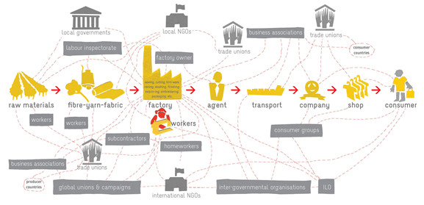
Figure 1.1: Representation of a supply chain and all the relationships it involves. Taken from the International Training Centre of the International Labour Organization briefing on global supply chains [4].

  - Challenge
One event, in particular, often caused delays are synchronization problems in the processes and information systems of a company. This is because companies value the privacy and security of their information. This means they may not want to share too much information. They may only be able to share it through secure channels and lack standards for sending information and communicating. So, it is very difficult for anyone to have a global overview of the supply chain.

  - From Blockchain Technology to Supply Chain
Though it was first proposed in its actual form by an anonymous group that published a white paper in 2008 [6], this was not the first reference to such technology.
The invention of the blockchain for bitcoin made it the primary virtual foreign money to resolve the double-spending hassle without the poverty of dependence on authority or imperative server. The 2nd innovation became known as the blockchain, which became basically the belief that the underlying era in operating bitcoin is separated from foreign money. It used for all varieties of different inter-organizational cooperation. The 3rd innovation became known as the "clever contract," embodied in a 2nd-technology blockchain gadget that constructed little pc packages without delay into the blockchain that allowed economic instruments, like loans or bonds, to be represented, in place of best the cash-like tokens.
Since then, it has come a long way, sprouting multiple different uses and applications of the technology (Kari, et al, 2017).

2. BLOCKCHAIN BASED SUPPLY CHAIN
Blockchain’s ability to assure the reliability, traceability, and authenticity of the information make the smart contractual relationships for trustless surroundings all portend a fundamental rethinking of supply chains and grant chain management. In this section, we will dive deeper into the cost proposition of blockchain science and its applicability to items and manufacturing supply chain, its structure, and the feasibility of new elements for managing a grant chain. How blockchain functions inside the context of the provide chain are nonetheless open to interpretation and development. Figure 2.1 suggests a regular graphic of one usual furnish chain transformation to a blockchain-based furnish chain.

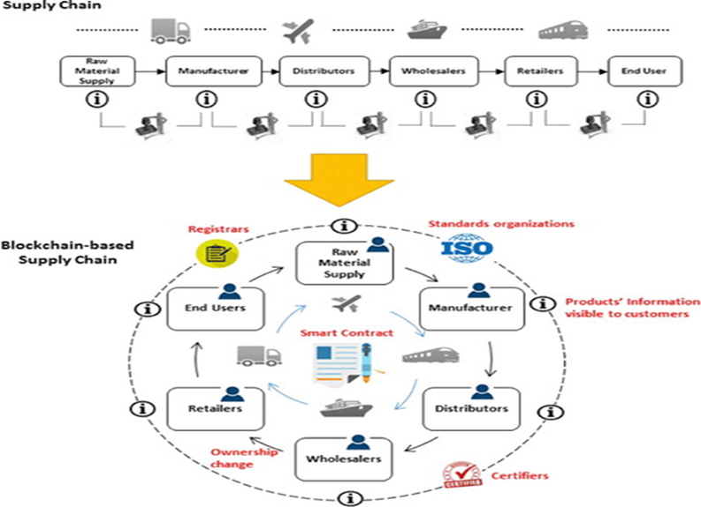
Figure 2.1: Supply chain transformation.

3 STATEMENT OF PROBLEM
The customer was not aware of all of the entities concerned within side the entire state of affairs and the recognition to approximately his/her product patron desires to request to the third-celebration vendor. For some reason, it offers an upward push for the problem of centralized entities that exist in the system. There are many purchasing web applications running as 3rd celebration in logistics.
In SCM, a product’s life cycle was able to be roughly divided into the many phases of the product. It started down from the raw materials to the finished product for the consumer.

- Speed of delivery. The faster the products arrived in their buyer, the faster the buyer can satisfy their needs. This held true not only for the final customer of a product, but it also provided products and services to other enterprises, be it in the role of supplier, manufacturers, distributors, or retailers for any enterprise.

- Synchronization. The real problem had occurred when the companies had no common ground and the data was not transmittable in an automatic way, leading to a lot of unnecessary manual work to export the data from one system and import it into another as follows:

- Lack of data integration standards development in the supply chain industry.

- Lack of a common technology to store all data, from where each company could have its own software extract the information from.

- Tracking. During a product’s lifetime, a lot of alterations occur and, sometimes, the records about the product flow were lost, falsified, or flat out in a registry. This lead to unreliability in the goods the consumers’ use every day and it might have occurred that some products were falsified and it was not an actual product to be advertised to be. Additionally, it was also able to happen that the products were not being properly tracked and it did not hold up to the conditions or required quality standards. This can sometimes even lead to safety hazards.

- Security. Information in a supply chain was highly sensitive and it should be controlled so that only trusted entities can access it. Therefore, the information was generated in the process of managing a supply chain might be too sensitive to share, in order to keep an edge on the competition.

- SOLUTION DESIGN AND IMPLEMENTATION RESULT

  - The Objectives:
- To develop tracking the products.
- To develop SC using Blockchain Technology.
- To increase the trust between various participants and bringing transparency in the supply chain.
- To use blockchain technology in tracking applications can achieve cost savings by more automated, error-free, and less of paperwork processes.
- To manage the ownership of digital assets and facilitate asset transfers.

The question, “Is it possible to build a feasible architectural design, by using such a tool, to implement all these requirements?” required that the elicited requirements be formed into a list and an architectural design to be built and implemented using the chosen framework. This chapter deal with explaining these tasks sequentially. These functionalities were directly based on some points of focus from this paper: synchronization, security, and tracking or traceability, so it was based on these attributes that the framework should also be selected.
Security: the improvement of information privacy in supply chains was not very important in itself. Some fraud verification checks should be supported.
Traceability: For the traceability requirements, the proposed system should be able to track all information, including changes in the system, registries of assets, transactions, network participants and organizations. Thus, the selected framework must support the management of data in the form of assets, entities and organizations, which should be accessible only to specific entities, including auditors.
Synchronization: As the source of fact, any external needed system to query or insert data should be easily accessible by the blockchain. The resulting synchronization specifications were included by the implementation of standards and devices interoperability for the exchange of information in real time.
Transaction Enforcement and Financial domain: There was an interest in financial applications, and cryptocurrencies were part of this. However, for financial applications to be feasible in the delivery chain, the use of blockchain, local blockchain cryptocurrencies was not always necessary. It was because cryptocurrencies were able to be simulated in the use of balances, depending on the layout of the blockchain network.
For this, the different functionalities to work, clever settlement capability had to exist, though. Thus, the chosen framework had to either have a local cryptocurrency or permit for the layout of a few forms of virtual stability or token. Additionally, it had to help clever contracts. These facts were summarized in Table 4.1.

Table 4.1: Summary of the framework requirements

Area | Framework Requirements
Security | Highly controlled environment
 | Authentication and authorization mechanisms
 | Fraud verifications (by smart contracts)
Traceability | Management of data: assets, entities, organizations
 | Data access controlled, but accessible to auditors
Synchronization | Expose data to the outside systems through APIs
 | Allow the use of predefined data formats
Transaction  Enforcement and  Financial domain | Smart Contracts
Native cryptocurrency or a way to simulate currencies or
account balance

  - Frameworks Choice
Firstly, the required private blockchain framework seemed more adequate because of all the security control mechanisms. Second, the framework must allow for a highly customizable network including not only asset management, but also identity management as well. It was done because blockchain participants can be granted special permission. Lastly, the framework needed to allow the use of the API.
Hyperledger Fabric - It had the needed mechanisms for authentication and authorization, and, similarly to the other frameworks, had smart contract capability. It was highly customizable, allowing for all the statistics and identity management needed. As for synchronization, it featured easy to deploy rest servers, which was also important. However, it had a setback, such as though it was customizable, it did not feature a native cryptocurrency. Therefore, financial transactions were possible, but only if designed from scratch to be simulated by the network

  - Requirements Specifications
The structure for this specification was able to somewhat resemble the organization of IEEE 830-1998 requirements specification standard (Oliviera, et. al., 2018), but in a simplified way, without some of the unneeded clutter and information. The specification was divided into the following way:
- Introduction - Product purpose, scope, overview, and users;
- Requirements - Specific requirements including functional requirements, non-functional or quality requirements, permission list, and design constraints.

  - Design and Implementation
Although a few initiatives construct complete or partly custom blockchain community software, the use of a framework like Hyperledger was a mile extra streamlined manner to get a quick functioning prototype. The layout might be divided into four elements namely, Model Design for a Business Network, Access Control Design and Identity Management, Network Topology and Deployment, Integrating Existing Systems, and Building External Applications.
These elements were not always sequential. However, following the indexed order might also additionally result in the best consequences in improvement. Since time changed into an issue and the dissertation already blanketed elements different than the improvement, the scope of the improvement itself could no longer be broad sufficient to encompass a deep exploration of all of the elements indexed. Therefore, the project here offered focuses extra at the first-class and useful elements of making use of blockchain to the deliver chain, and now no longer a lot at the quantitative part, which could encompass exams to the performance of the community.
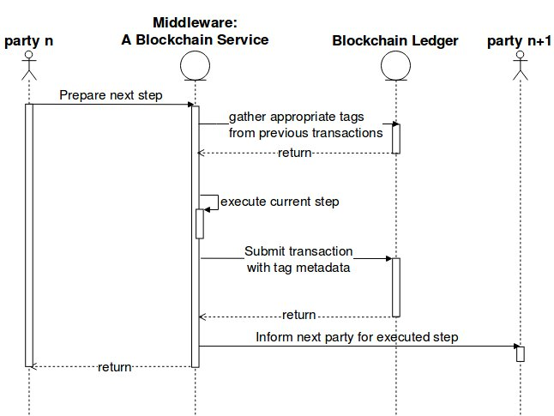
Figure 4.1 Case Diagram for Design Blockchain Tracking Supply Chain

Figure 4.1. One supply chain (stage number n+1) was a blockchain transaction. Every stage’s functionality was automated by the "Middleware". Thus, the parties that participate in each stage (a single one in the input and another one in the output) had a small interaction with it; for instance, confirmed that the transportation was completed by receiving the appropriate transaction hash, or the employee confirmed that certain materials were kept refrigerated, as expected, by collecting the corresponding transaction hashes and others. Here, party n participates in stage n+1 input (and already in stage n output) while party n+1 participates in stage n+1 output (and stage n+2 input).

  - Result
Result of this paper, it should be an application based mobile with following script of Solitude

import "./Manager.sol";

contract ShipmentTracking is main{

event DepartedFromOnePort(uint shipmentId);
event ArrivedAtAnotherPort(uint shipmentId);

uint shipmentId;
uint orderId;

function stateRequiredTimeToNextEntity(uint _orderId, uint _requiredTime){ // Give Estimate;

statsMap[_orderId].timeToNextEntity = _requiredTime;
}

function arrived(uint shipmentId) public
{
require(msg.sender==flowOfObject[orderId].Addresses[currentaddress[orderId]]);
statsMap[orderId].checkPoint="ArrivedAtNearestPort"; // Updates currentStatusOfOrder.
statsMap[orderId].timeTheEventCalled=now;
transferPossesion(orderId);
ArrivedAtAnotherPort(shipmentId);
}

function departured(uint shipmentId, string shipagentname) public
{
statsMap[orderId].checkPoint="DepartedFromThePort"; // Updates currentStatusOfOrder.
statsMap[orderId].timeTheEventCalled=now;
DepartedFromOnePort(shipmentId);
}
}

5. Conclusions
The blockchain was introduced to achieve the supply chain’s objectives, by reducing the risk emerging from the tracking system and data management.

- Deploying blockchain in the supply chain ecosystem brought many benefits, notably:
- Created more transparent and accurate end-to-end tracking
- Increased trust between the producer and consumer, by improving visibility and product compliance with international standards
- Reduced paperwork and administrative costs
- Reduced or eliminating fraud and counterfeit products
- Facilitated origin tracking
- Recalled a product in a time-efficient way.

However, integrating the blockchain into the supply chain ecosystem brought important new challenges notably on the blockchain level. We needed to consider the properties and capabilities of available blockchain implementations before choosing the most suitable blockchain for such an ecosystem. In building a blockchain-based supply chain management, we needed to take into consideration not only the blockchain technology suitable to our business, but it was also the reliability of collected data.
Storing reliable information required a reliable interaction between the blockchain and all ecosystems’ constituents (These consisted of tracking devices and actors).
In building a blockchain-based supply chain, we needed to consider these requirements:

- Selected a blockchain according to different key criteria notably: Throughput, latency, capacity, and scalability (A multi-criteria decision-making can be applied to choose the most suitable blockchain into our deployed ecosystem.) (Onno, et. al, 2019)
- Implemented a dual storage architecture to handle a large amount of data, without degrading the blockchain performance (An additional private blockchain could be introduced to the system architecture.)
- Chose the tracking devices based on the main product criteria we want to track or monitor
- Chose the communication protocol based on the speed, data rate, communication range, power consumption, cost, or any criteria deemed essential in the supply chain environment Try to fill the security vulnerabilities found in the communication protocol to provide a secure and reliable traceability system
- Created a secure tracking environment beginning by authenticating the system tracking devices and making sure all transferred or collected data is encrypted and signed.

References
Kewell, B., Adams, R., & Parry, G. (2017). Blockchain for good?. Strategic Change, 26(5), 429-437.
Nofer, M., Gomber, P., Hinz, O., & Schiereck, D. (2017). Blockchain. Business & Information Systems Engineering, 59(3), 183-187.
Fan, H., Li, G., Sun, H., & Cheng, T. C. E. (2017). An information processing perspective on supply chain risk management: Antecedents, mechanism, and consequences. International Journal of Production Economics, 185, 63-75.
International Training Centre of the International Labour Organization. Understanding global supply chains, 2018
Busse, C., Meinlschmidt, J., & Foerstl, K. (2017). Managing information processing needs in global supply chains: A prerequisite to sustainable supply chain management. Journal of Supply Chain Management, 53(1), 87-113.
Korpela, K., Hallikas, J., & Dahlberg, T. (2017, January). Digital supply chain transformation toward blockchain integration. In proceedings of the 50th Hawaii international conference on system sciences.
Mendling, J., Weber, I., Aalst, W. V. D., Brocke, J. V., Cabanillas, C., Daniel, F., ... & Gal, A. (2018). Blockchains for business process management-challenges and opportunities. ACM Transactions on Management Information Systems (TMIS), 9(1), 1-16.
Nakamoto, S., & Bitcoin, A. (2008). A peer-to-peer electronic cash system. Bitcoin.–URL: https://bitcoin. org/bitcoin. pdf, 4.
Oliveira, M. P. V. D., & Handfield, R. (2019). Analytical foundations for development of real-time supply chain capabilities. International Journal of Production Research, 57(5), 1571-1589.
Huertas, J., Liu, H., & Robinson, S. (2018). Eximchain: Supply Chain Finance solutions on a secured public, permissioned blockchain hybrid. Eximchain white paper, 13.
Pongnumkul, S., Siripanpornchana, C., & Thajchayapong, S. (2017, July). Performance analysis of private blockchain platforms in varying workloads. In 2017 26th International Conference on Computer Communication and Networks (ICCCN) (pp. 1-6). IEEE.
Prokle, M. (2017). Theory and Practice of Supply Chain Synchronization.
Scherer, M. (2017). Performance and scalability of blockchain networks and smart contracts.
Purbo OW, Sriyanto S, Irianto SY, RZ Abdul Aziz, Herwanto R. 2019, Benchmark and comparison between hyperledger and MySQL. TELKOMNIKA Telecommunication, Computing, Electronics and Control Vol. 18, No. 2, April 2020, pp. 705~715 2019
Herwanto, Riko. "BENCHMARK AND COMPARISON BETWEEN HYPERLEDGER AND MYSQL." Master Thesis., Darmajaya, 2019.

