**CHAPTER 1**

**INTRODUCTION**

* 1. **BACKGROUND**

We have entered an age where everything is connected to theInternet. The use of Information Technology (IT) currently covers almost all areas of life and demand human performance to be faster, easier, and computerized. According to Wikipedia, The internet is a global computer network that connects the world in one network. Internet can provide all the information needed by the community. The internet can also be used in searching data or information to facilitate the flow of information and communication needed by the public.

PT. Al Madinah Munawarah is a Hajj and Umrah travel service bureau, every year it serves prospective pilgrims to leave for Hajj and Umrah. The existing information system at PT. Al Madinah Munawarah is currently not computerized. Prospective pilgrims for Hajj and Umrah still register manually, such as filling out registration forms which take up a lot of spaces for storage and require time to search for prospective pilgrims' data making the service section difficult. In addition, making payment reports resulted in the financial department taking a long time because they had to collect to payment receipts, and then transferred them to the computer.

Therefore, the website is an alternative means of providing up to date information to prospective pilgrims for Haj and Umrah PT. Al Madinah Munawarah in registration, payment, services and data availability. So that it is easy to computerize in managing data for pilgrims who use the company's Haj and Umrah services.

Dynamic web is a type of web whose content can change at any time (webarq.com). To create a static web page you can use several web applications or it can be called web-based software, of them is Sublime Text, which is widely used by programmers, designers and web developers due to its ease of use, completeness of its features and its support for the latest technology. With various advantages and features of the Sublime Text 3 software and XAMPP, the authors use this application to create a dynamic website that contains information on the availability and services of Haj and Umrah PT. Al Madinah Munawarah and users can order online through the menu available on the Hajj and Umrah Tour website of PT. Al Madinah Munawarah.

**1.2 RESEARCH QUESTION**

Based on the background of the existing problems, the formulation of the problem can be taken, namely "*How to design a dynamic website-based hajj and Umrah service information system that will be apply by PT. Al Madinah Munawarah using Sublime Text 3*? ”.

**1.3 THE SCOPE**

To gain an in-depth understanding, the author limits the discussion in this practical work report only to the scope of the web page which contains registration requirements, provides information about rituals and departures, pilgrimage packages and Umrah payment services, and hajj or umrah registration quotas up to 50 people. It is further shortens the time in making the website.

**1.4 PURPOSE**

This research has the following objectives:

1. Apply knowledge and knowledge gained during the lecture period in the form of writing practical work reports, and to meet academic requirements to obtain the value of the Job Training course.
2. The purpose of this research is to create a web page for personal or e-commers web such as a website in building an information system for Hajj and Umrah services of PT. Al Madinah Munawarah as a service medium for prospective congregations online by choosing their facilities, and services available.

**1.5 BENEFITS**

1. Able to create web pages dynamically

2. Benefits for beginners to be able to create a website with a lightweight editor.

3. Benefits This research is able to create e-commers web pages and personal web.

**1.6 SYSTEMATIC**

**Chapter I Introduction**

This chapter contains the background of the problem, the formulation of the problem, the scope of the research, the objectives, and benefits of the research and the systematic of writing.

**CHAPTER II Literature Review**

This chapter contains basic theories related to the research conducted by the author.

**CHAPTER III Research Methods**

This chapter describes the problem-solving framework, data collection methods, problem analysis, object objectives, and methods used.

**CHAPTER IV Results and Discussion**

This chapter contains the results of creating web pages using the Sublime Text 3 application in the form of a static and dynamic website consisting of 6 web pages. Among them, the start page has a display of several menu options, namely Home, Profile, Price Hajj Umrah, Packet Tour, Contact Us, Book Now.

**CHAPTER V Closing**

This chapter contains conclusions and suggestions related to the discussion in this practical work report.

**CHAPTER II**

**LITERATURE REVIEW**

**2.1 Internet**

The Internet is a collection or network of computers around the world. The Internet (short for interconnection-networking) is literally a global system of all connected computer networks using the standard Internet Protocol Suite (TCP / IP) to serve billions of users around the world.

Understanding the internet according to experts:

2.11 Lani Sidharta (1996) stated that the internet is an interconnection of a computer network that can provide complete information services. And, it is evident that the internet is seen as a virtual medium that can be a partner in business, politics, and entertainment. Everything is presented in full in these media.

2.1.2 Khoe yao tung stated that the internet is a network of communication satellites whose functions are very diverse and certainly supports the internet throughout the world.

Based on the two cites above, it can be concluded that the internet is a communication network between large computers, covering the entire world and based on a protocol called TCP / IP (Transmission Control Protocol / Internet protocol). In addition, the internet can be called an information resource that can be used by the whole world in searching for information.

**2.2 Website**

In this world of fast technology, we need a network that can facilitate and accelerate the delivery of information widely, and can be easily and quickly by anyone with internet access. According to Bekti (2015) concluded that: A website is a collection of pages used to display to text information, still or motion images, animation, sound, and / or a combination of all of them, both static and dynamic which form a series of buildings interconnected, each linked by the networks of pages.

**2.2.1 Type of Website**

According to Ippho Santoso in Rahmadi (2013), dividing the website into right and left groups. The website is known as dynamic website and static website.

**2.2.1.1. Static website**

Static websites are websites that have content pages that don't change.

**2. 2.1.2 Dynamic website**

Dynamic websites are websites that are structurally intended to be updated as often as possible.

**2.3 PHP**

PHP or short for Hypertext Preprocessor is an open source programming language that is very suitable or specifically for web development and can be embedded in an HTML thesis. PHP language can be said to describe several programming languages ​​such as C, Java, and Perl, and is easy to learn. PHP is a server-side scripting language, where data processing is done on the server side. Simply put, the server will translate the program script, then the results will be sent to the client who makes the request. Another definition of PHP is the acronym for Hypertext Preprocessor, which is a programming language based on codes (scripts) that are used to process data and send it back to the web browser into HTML code. According to Kustiyaningsih (2011), "PHP (or formally PHP: Hypertext Preprocessor) is a server-side script that is added to HTML"

In principle, the server will work when there is a request from the client. In this case the client uses PHP codes to send requests to the server. The working system of PHP begins with requests that come from web pages by the browser. Based on the URL or website address in the internet network, the browser will find an address from the web server, identify the desired page, and deliver all the information needed by the web server.

**2.4 Database**

Database According to Sukamto and Saladin (2014), a database is a medium for storing data, so that, it can be accessed easily and quickly. Kristanto (2008), a database is a collection of data, which can be described as the activities of one or more related organizations.

**2.5 Data Flow Diagrams (DFD)**

Sukamto and Saladin (2014), Data Flow Diagrams (DFD) or in Indonesian became Data Flow Diagrams (DAD).

Data Flow Diagrams (DAD) are graphical representations that describe the flow of information and information transformations that are applied as data flowing from input (input) and output (output).

**2.6 Sublime Text 3**

Sublime Text 3 is the latest version of the popular text editor Sublime Text. This is a full featured text file that's great for editing local text files. It has many built-in features to aid in code editing, such as syntax highlighting, auto-identification, file type recognition, handy file / Molder sidebar for easy editing of multiple files in a directory, macros for automating repetitive tasks, and separate tab and window options. To view and edit multiple files simultaneously. With a lot of programmer-centered sublime text features, taking advantage of this editor increases productivity (Eric Haugee, 2013).

**2.7 MySQL**

Raharjo (2015), MySQL is an RDBMS (or database server) software that can manage databases very quickly, can accommodate very large amounts of data, can be accessed by multiple users (multi-user), and can perform a process synchronously or simultaneously (multi-threaded).

Sujatmiko (2012), SQL (Structured Query Language) is a language used to access to data in relational databases. This language is de facto the standard language used in relational database management.

**CHAPTER III**

**RESEARCH METHODS**

**3.1 *Design of Data Flow Diagrams* (DFD)**

Data Flow Diagram (Wikipedia.com) is a diagram that uses notations to describe the flow of system data, the use of which is very helpful for understanding the system logically, structured and clearly. DFD is a tool to describe or explain the system that is running logically.

3.1.1 DFD level 0

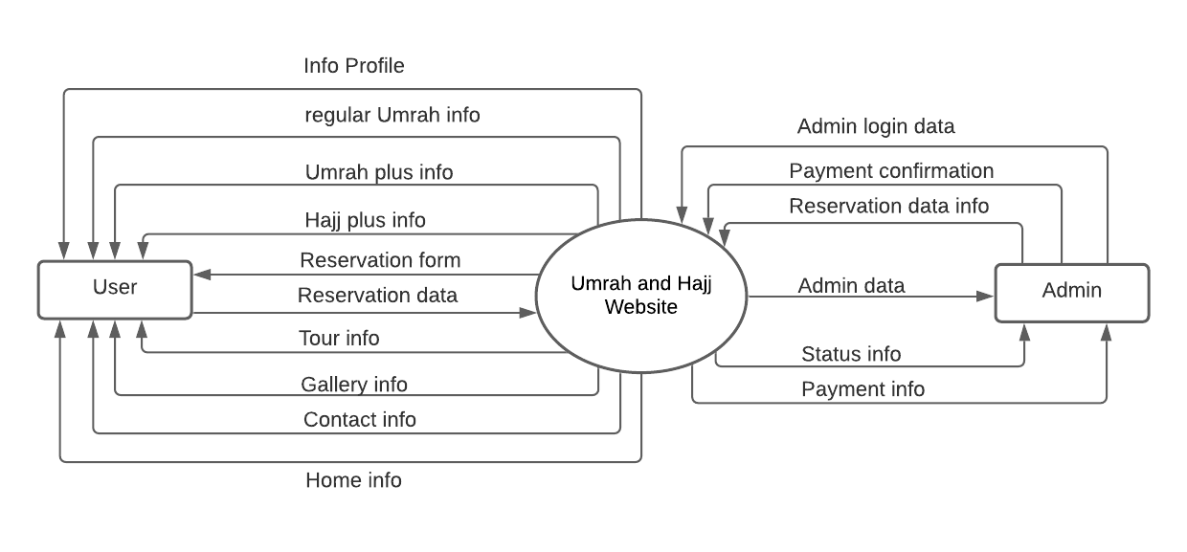

CONTEXT DIAGRAM

* + 1. DFD LEVEL 1

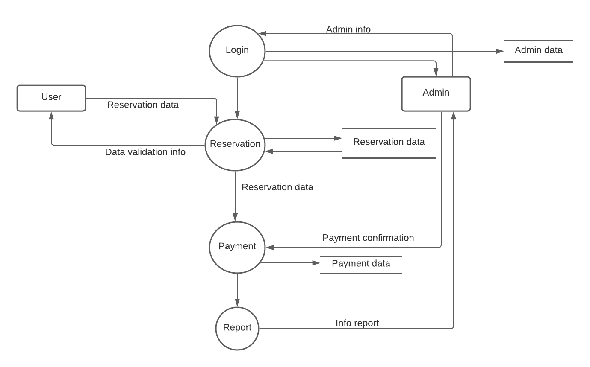

**3.2 Database Design Plan**

Tables required

a. Login table

b. Payment table

c. Tour booking table

d. Tour table

1. Table Login

|  |  |  |
| --- | --- | --- |
| No | Name Field | Type |
| 1 | Id_admin | Int(10) |
| 2 | Usname | Varchar(30) |
| 3 | Pass | Varchar(30) |

1. Table payment

|  |  |  |
| --- | --- | --- |
| No | Name field | Type |
| 1 | Id_payment | Int(12) |
| 2 | Title | Varchar(5) |
| 3 | Fname | Varchar(30) |
| 4 | Lname | Varchar(30) |
| 5 | Tumrah_hajj | Varchar(30) |
| 6 | Ttour | Varchar(30) |
| 7 | Tairlines | Varchar(30) |
| 8 | Cdeparture | Date |
| 9 | Creturn | Date |
| 10 | Ttot | Double(8,2) |

1. Table tour booking

|  |  |  |
| --- | --- | --- |
| No | Name field | Type |
| 1 | Id | Int(12) |
| 2 | Title | Varchar(5) |
| 3 | Fname | Text |
| 4 | Lname | Text |
| 5 | Email | Varchar(50) |
| 6 | National | Varchar(30) |
| 7 | City | Varchar(30) |
| 8 | Vilage | Varchar(30) |
| 9 | Status | Varchar(8) |
| 10 | Phone | Text |
| 11 | Tumrah_hajj | Varchar(30) |
| 12 | Ttour | Varchar(30) |
| 13 | Tairlines | Varchar(30) |
| 14 | Cdeparture | Date |
| 15 | Creturn | Date |

1. table tour

|  |  |  |
| --- | --- | --- |
| No | Name field | Type |
| 1 | Id | Int(10) |
| 2 | Umrah | Varchar(10) |
| 3 | Hajj | Varchar(10) |
| 4 | Tour | Varchar(30) |
| 5 | Airlines | Varchar(30) |

**3.3 Design Interface Design**

The display design is used to make it easier to build applications. The following will explain the design of each screen that will display in this application.

1. Page Display Design *Home*

|  |  |  |  |  |  |  |
| --- | --- | --- | --- | --- | --- | --- |
| Home  logo | profile | Umroh and Hajj | Packet Tour | Galery | Contact Us | Book Now |

Background Tour Umrah and Hajj

1. Page View Design *Profile*

|  |  |  |  |  |  |  |
| --- | --- | --- | --- | --- | --- | --- |
| Home  logo | profile | Umroh and Hajj | Packet Tour | Galery | Contact Us | Book Now |

Profile Tour Umrah and Hajj

1. Page View Design *Umrah dan Hajj*

|  |  |  |  |  |  |  |
| --- | --- | --- | --- | --- | --- | --- |
| Home  logo | profile | Umroh and Hajj | Packet Tour | Galery | Contact Us | Book Now |

Packet Hajj Plus

Packet Umrah Regular

penjelasan

Packet Umrah Plus

1. Page View Design *Packet Tour*

|  |  |  |  |  |  |  |
| --- | --- | --- | --- | --- | --- | --- |
| Home  logo | profile | Umroh and Hajj | Packet Tour | Galery | Contact Us | Book Now |

Bali 4D3N

[Jogyakarta Tour 4D3N](http://www.madinahtours.com/adm/index.php/news/edit/2)

[Surabaya, Batu Dan Bromo 4D3N](http://www.madinahtours.com/adm/index.php/news/edit/4)

[Lombok Tour 4D3N](http://www.madinahtours.com/adm/index.php/news/edit/5)

[Bali 3D2N](http://www.madinahtours.com/adm/index.php/news/edit/6)

Umroh Plus Dubai Makkah – Madinah – Dubai

[Umroh Plus Turkey 13 Hari](http://www.madinahtours.com/adm/index.php/news/edit/8)

Paket Umroh Plus Hongkong  [Umrah Plus Al-Aqsa Plus Kairo](http://www.madinahtours.com/adm/index.php/news/edit/9)

1. Page View Design *Galery*

|  |  |  |  |  |  |  |
| --- | --- | --- | --- | --- | --- | --- |
| Home  logo | profile | Umroh and Hajj | Packet Tour | Galery | Contact Us | Book Now |

Foto

Foto

Foto

Foto

Foto

Foto

Foto

Foto

1. Page View Design *Contact Us*

|  |  |  |  |  |  |  |
| --- | --- | --- | --- | --- | --- | --- |
| Home  logo | profile | Umroh and Hajj | Packet Tour | Galery | Contact Us | Book Now |

Foto

Info Contact

1. Page View Design *Book Now*

Logo tour

hotel

Tour International

</div></div>

</div>

Tour Domestic

</div></div>

</div>

Hajj Plus

</div></div>

</div>

Umrah plus

Umrah Reguler

Fill Data Information

**3.4 Data Collection Methods**

Data collection activities can use various ways, namely as follows:

1. Literature review data collection by studying and analyzing materials in the form of books, reports, and documents that support and related to the title of this report.

2. Observation (Observation), namely collecting data by making direct observations and collecting data on the object under study.

**3.5 Problem Analysis**

Based on the activities carried out, the problems are as follows:

a. How to make a website using Sublime Text 3?

b. Do create web pages use Sublime Text can it integrate properly?

Based on the analysis of the above problems, the writer tries to create a website using Sublime Text 3. Where the making of this website aims to provide easy access to hotel information and facilities as well as for online bookings. This website is dynamic and uses a local host.

**3.6 Tools Used**

Tools used to create this static website are using the Sublime Text 3 application. The first stage to start creating this web page is to install the Sublime Text 3 application or software on lab computers and apply compulsory courses, so that, students can easily implement and run this application on each computer so that the introduction of creating this static website runs well.

**CHAPTER IV**

**RESULTS AND DISCUSSION**

**4.1 Results**

In creating a dynamic *website* using *Sublime Text 3*, the following results are obtained:

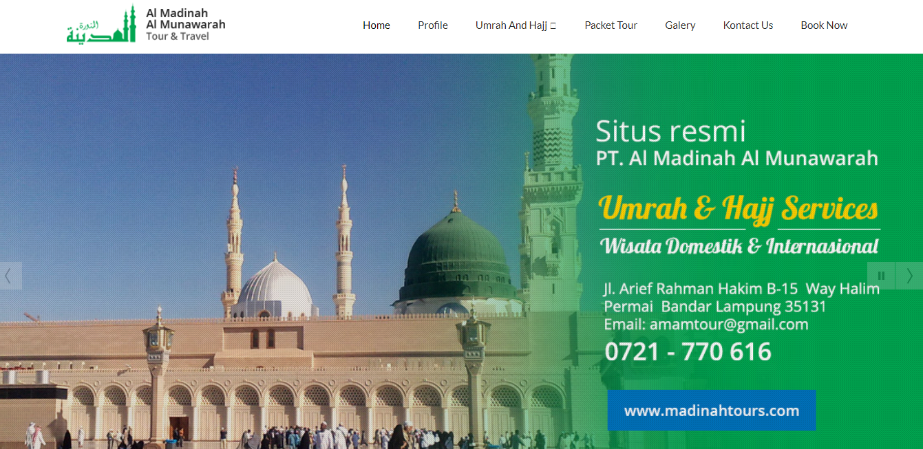

**Picture 4.1 menu home**

On the start page / home menu contains content about the background of the Umrah and Hajj tours accompanied by the Al Madinah Al Munawarah logo. Additionally, there are menus such as home, profile, Umrah and Hajj packages, packet tours, galleries, contact us, booking now.

**4.2 Discussion**

**4.2.1. Web Page Views**

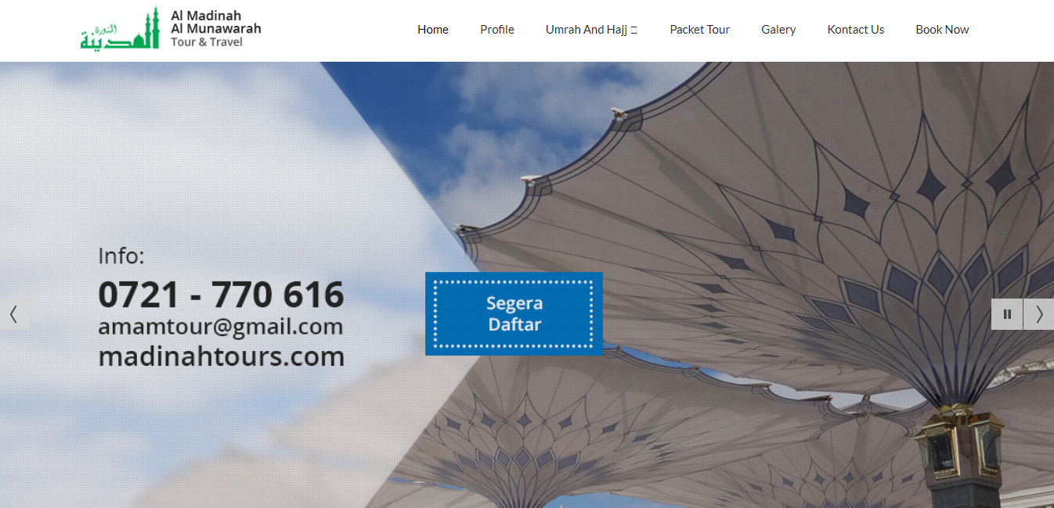

**Picture 4.1 Home page**

In making and designing the initial page *home*, the author added the background of the Quba mosque with the font face = "Julius + Sans + One". So that the initial appearance becomes the first interest to show the luxury of religious tourism, the author uses a simple design for the initial appearance of the website but still attractive.



**Picture 4.2 Profile page**

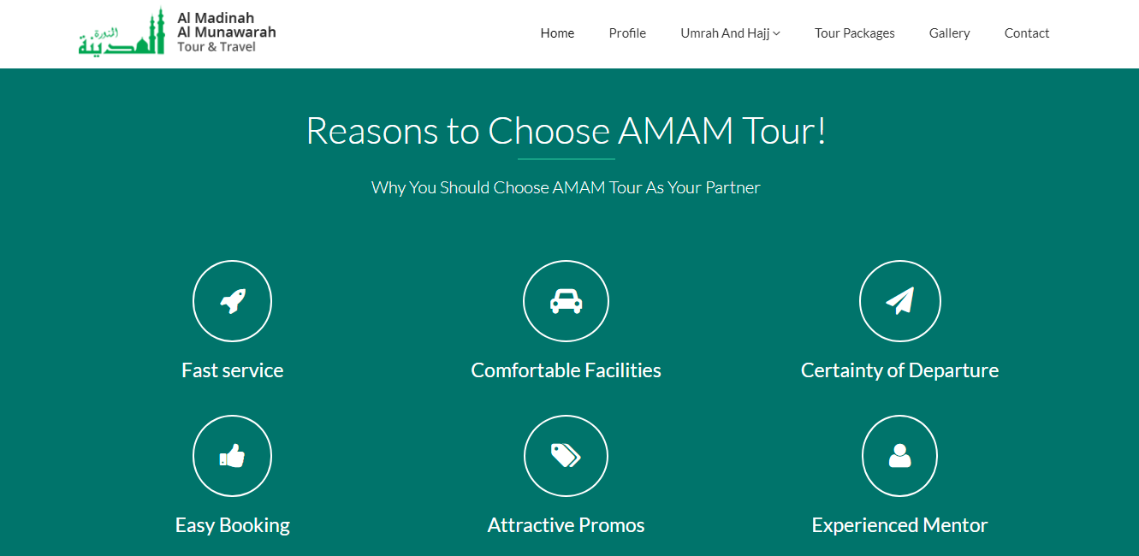

**4.3 Profile page**

On the *Profile* menu, there are several explanations and reasons for a company that can be trusted as well as a vision and mission that attracts tourists to book on Amam Tour. There are many facilities provided a fast service, certainty of departure, easy bookings, attractive promos, and experienced guides.

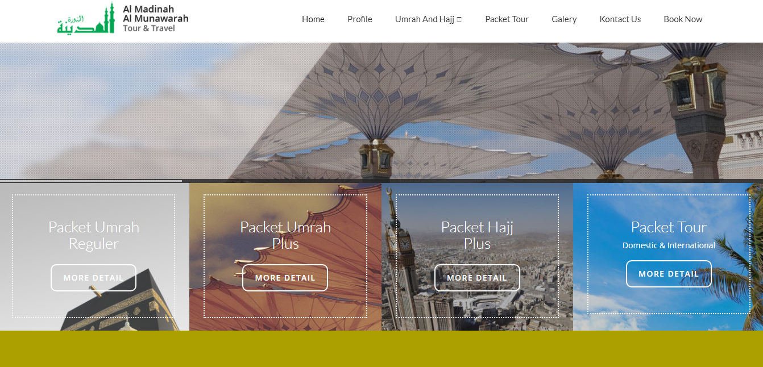

**Picture 4.4 Umrah and Hajj page**

On the *Umrah and Hajj* menu, there are several explanations and detailed information from a religious tourism company regarding prices, and all available facilities.

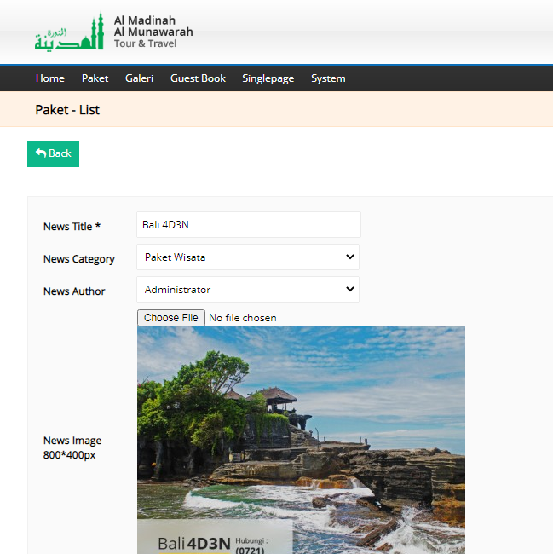

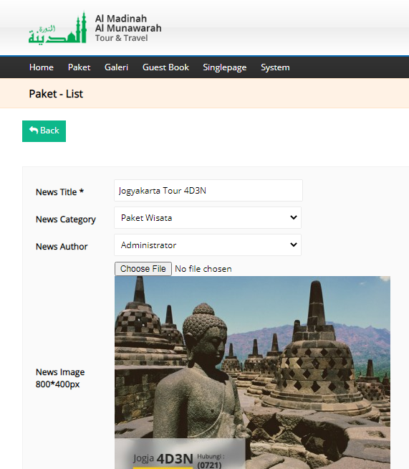

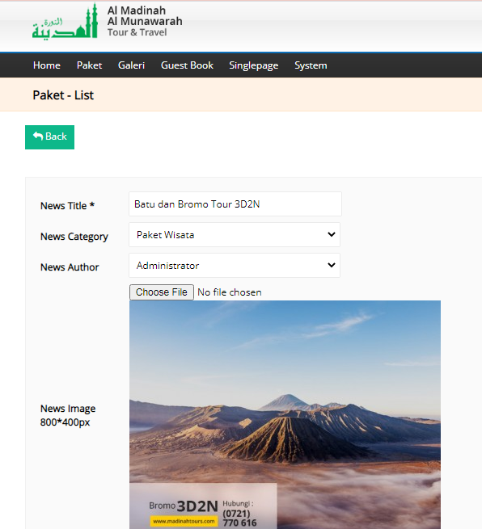 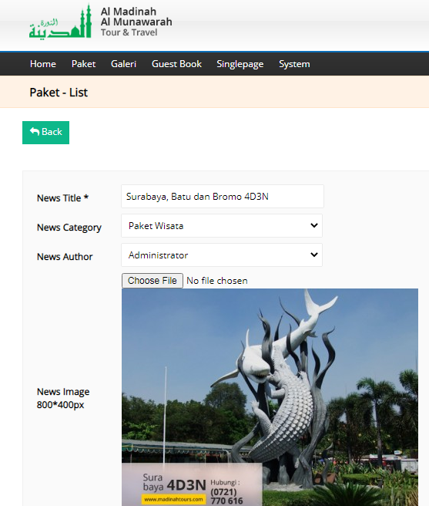

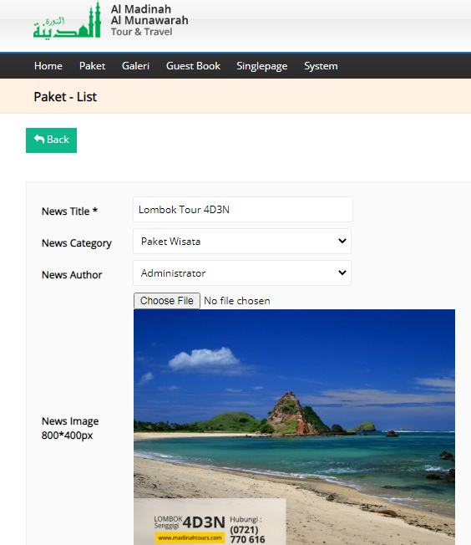 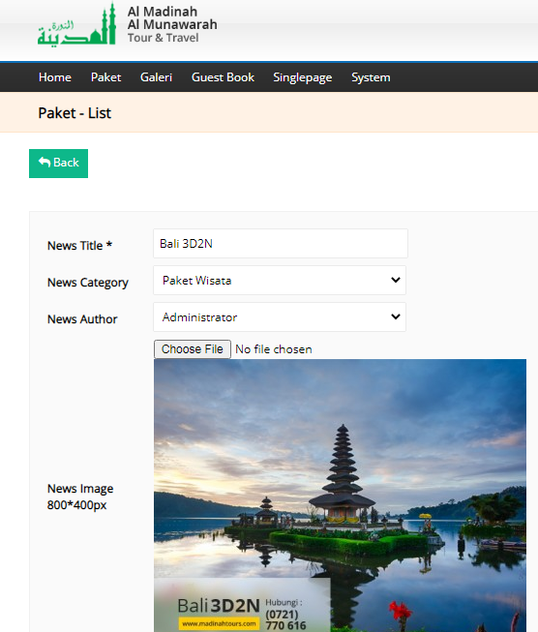

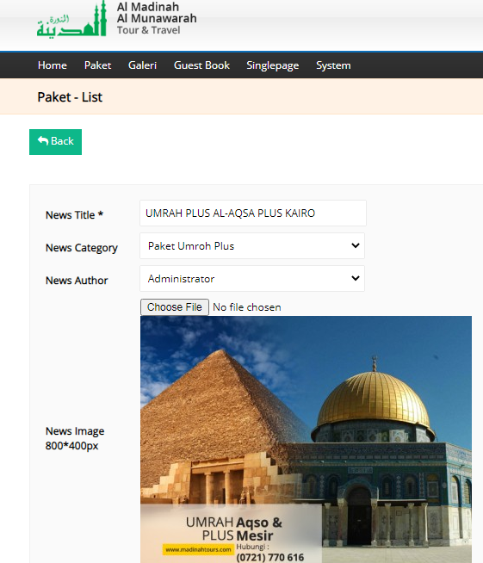

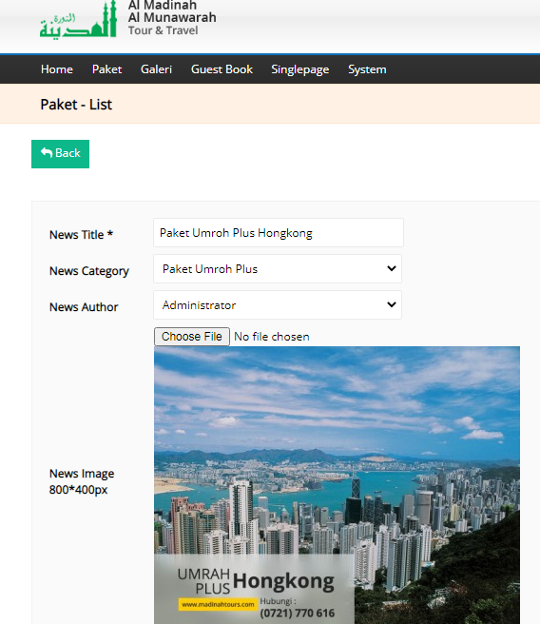

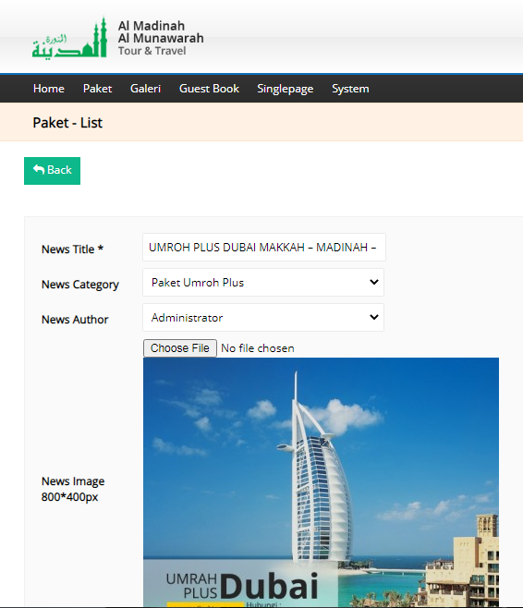

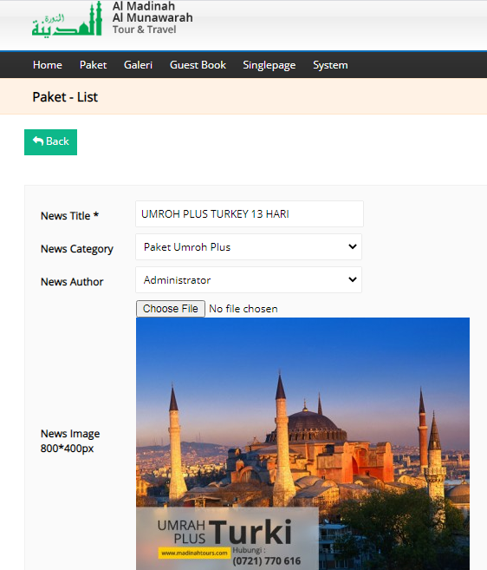

**Picture 4.5 Galery Page**

On the *Gallery* page, there are several services for religious tourists to choose the place they want to visit. In this section the special menu uses the <figure> </figure> tag to display photos with a slider element to make the appearance more elegant and modern and the website more attractive.

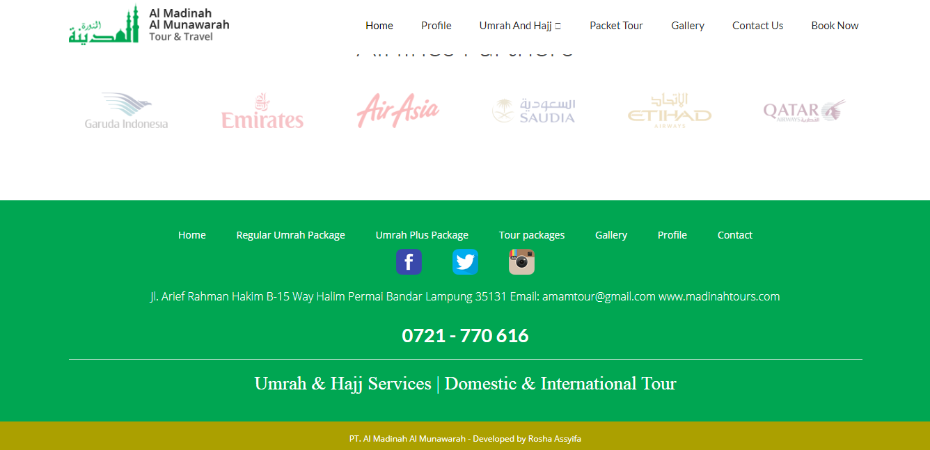

**Picture 4.6 Contact Us page**

On the *Contact Us* page, there are various information on phone numbers, Facebook, Twitter, Instagram, numbers and email additions which make it easier for tourists to choose the tour package, they want and can book a room directly with the option "Booking Now" and then fill out the reservation form.

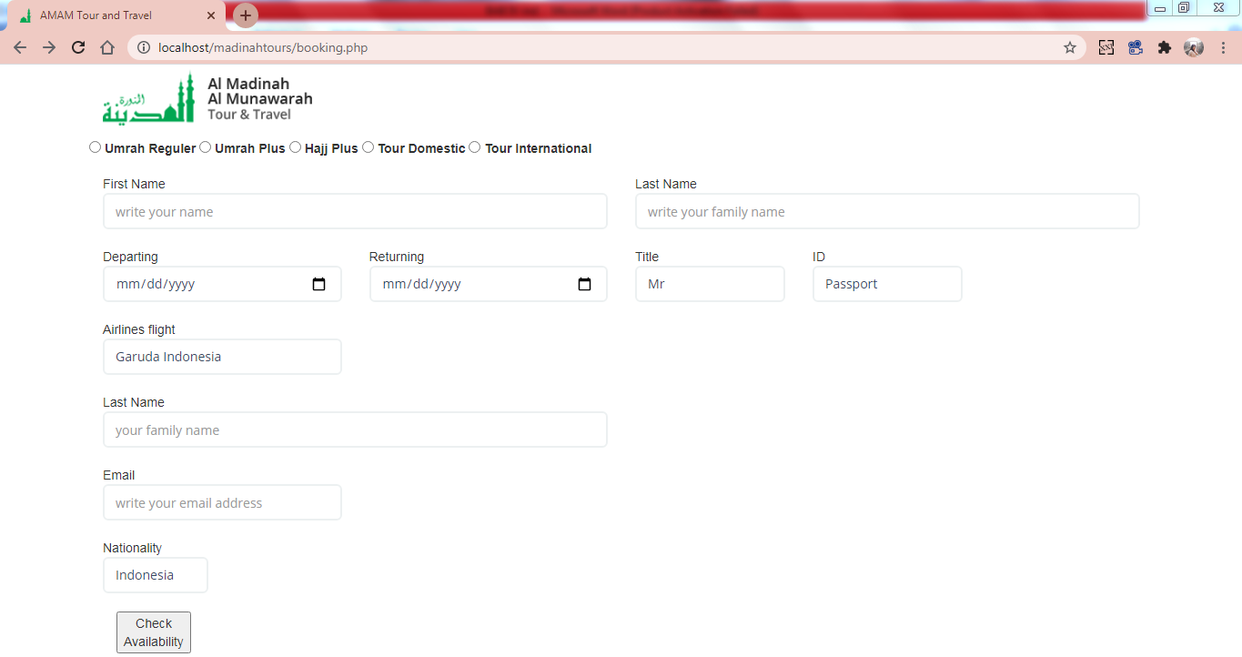

**Picture 4.7 Booking Now page**

**CHAPTER V**

**CLOSING**

**5.1 Conclusion**

From the explanation and description and discussion of all material in the previous chapters and at the end of the discussion on creating a website using Sublime Text 3, the authors conclude that:

1. A simple website on Umrah and Hajj tours can be built using Sublime Text and MySQL application programs.

2. In creating and designing dynamic websites using Sublime Text 3 it makes it easier for beginner programmers to use Sublime Text 3 which is lightweight and has an attractive coding appearance, and there are also excellent features that make sublime text has more value in the eyes of programmers and designers. In addition to its relatively light size, the advantages of Sublime Text 3 features such as typing program syntax quickly, making comments quickly, moving syntax lines quickly, multiplying syntax lines quickly and changing many syntax as well as being is very helpful in making programs fast and structured.

3. Implementing the introduction of making websites using Sublime Text 3, it can be applied to every campus lab at the lecture site so that students can easily use this application to get to know more about how to make a simple website using Sublime Text 3 with a relatively light size.

**5.2 Future work**

The suggestions that can be given are as follows:

1. It is hoped that the introduction of creating dynamic websites using Sublime Text 3 can produce new breakthroughs by the way of student’s learning that is more effective if later they will take their final project on creating static and dynamic websites. Therefore, the author only limits the appearance of the information provider and website-based ordering.

2. To avoid data loss, data backup should be done as often as possible, apart from the archives being stored, thus the media used is very sensitive, backing up data must be done so that the data is safer.

3. It is hoped that it will become a material consideration for the Institution to pay more attention to and improve facilities for students, especially the labs where lectures are to install this application.

4. It is hoped there will be socialization about this application to students through workshops or various competitions on website creation and design.