Lampiran 1

Sosial Media UMKM Kue Sagon

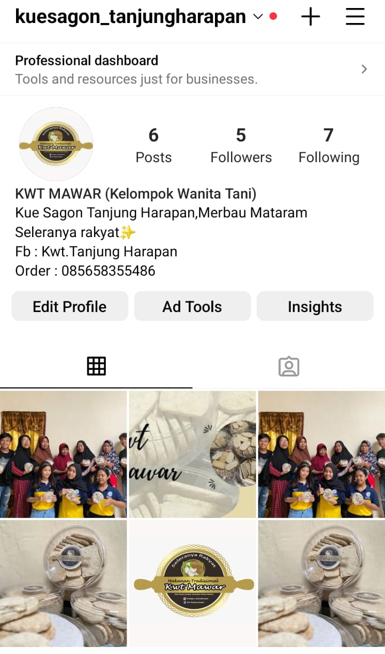

Lampiran 2

Banner UMKM Kue Sagon
